methodology for producing the regional parks system annual use estimate



The Council’s mission is to foster  
efficient and economic growth for   
a prosperous metropolitan region

**Metropolitan Council Members**

|  |  |
| --- | --- |
| Alene Tchourumoff Chair Katie Rodriguez District 1 Lona Schreiber District 2 Jennifer Munt District 3 Deb Barber District 4 Steve Elkins District 5 Gail Dorfman District 6 Gary L. Cunningham District 7 Cara Letofsky District 8 | Edward Reynoso District 9 Marie McCarthy District 10 Sandy Rummel District 11 Harry Melander District 12 Richard Kramer District 13 Jon Commers District 14 Steven T. Chávez District 15 Wendy Wulff District 16 |

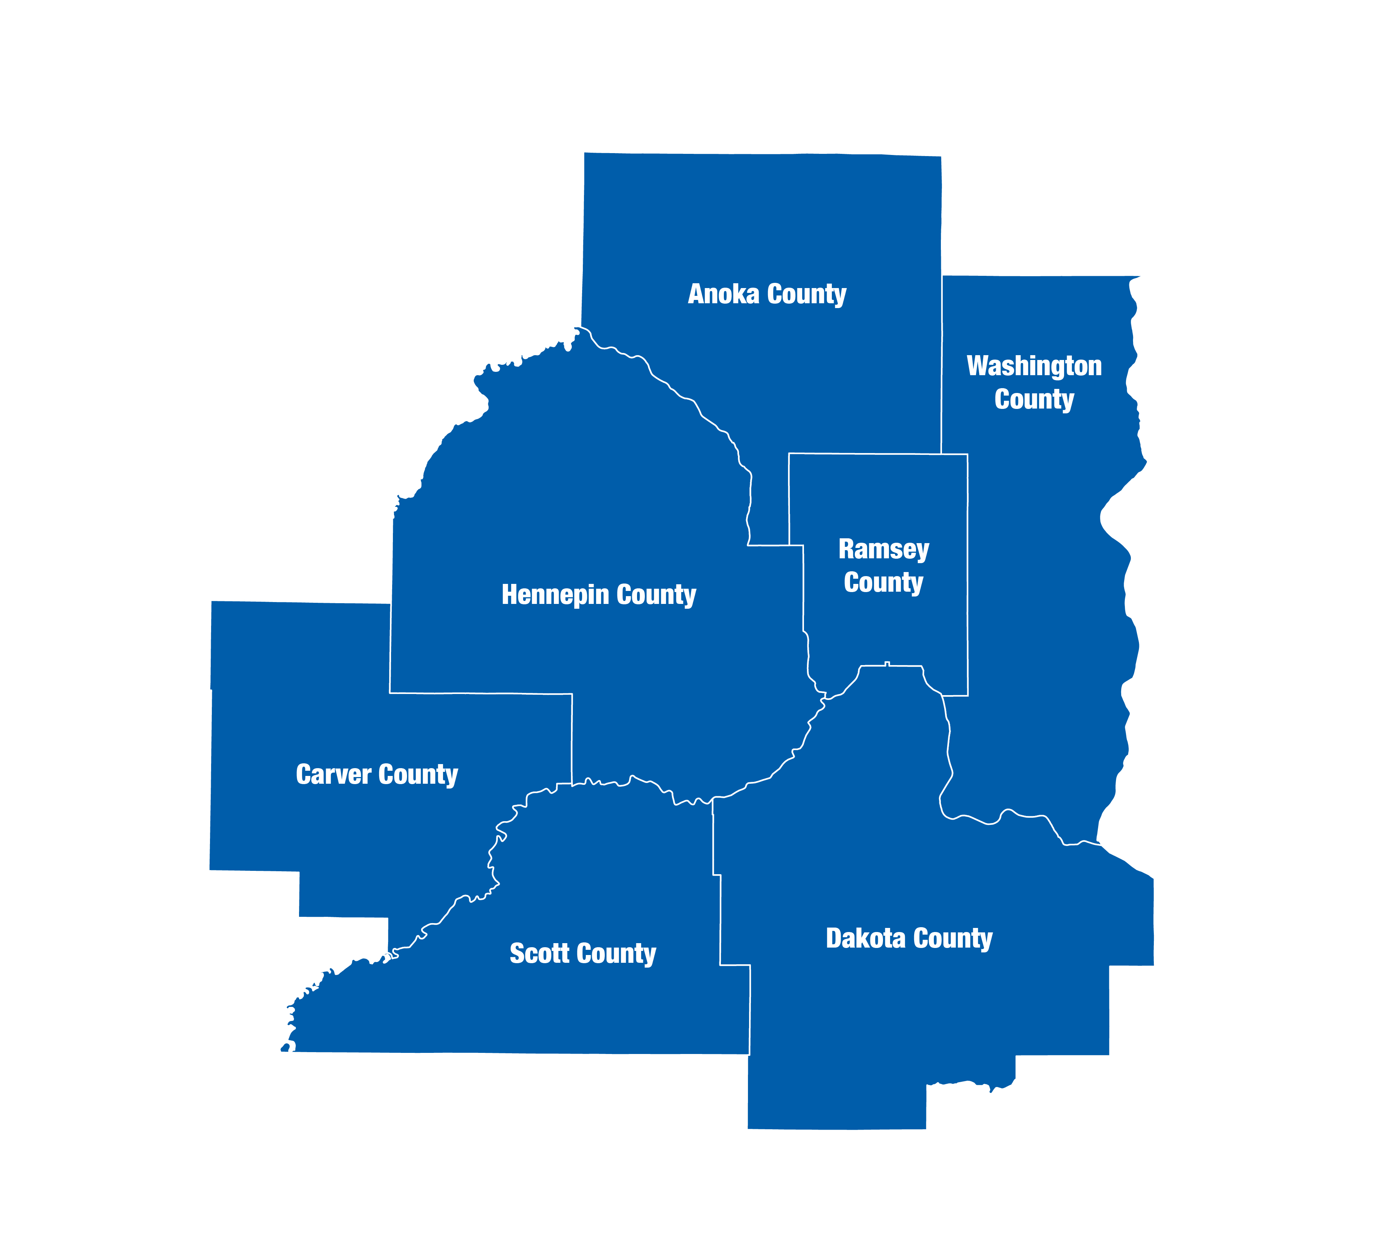

The Metropolitan Council is the regional planning organization   
for the seven-county Twin Cities area. The Council operates the regional bus and rail system, collects and treats wastewater, coordinates regional water resources, plans and helps fund regional parks, and administers federal funds that provide housing opportunities for low- and moderate-income individuals and families. The 17-member Council board is appointed by and serves at the pleasure of the governor.

On request, this publication will be made available in alternative formats to people with disabilities. Call Metropolitan Council information at 651-602-1140 or TTY 651-291-0904.

# Introduction

The seven-county Twin Cities metropolitan area is home to a system of regional parks and trails that are nationally renowned for their beauty, size and variety of features. With 55 regional parks and preserves, comprising over 54,000 acres, nearly 400 miles of regional trails, and eight special recreation features, the system provides a wealth of opportunities for recreation, exercise, and just plain fun. It also preserves significant green space and wildlife habitat.

The Regional Parks System is operated by 10 partner agencies, including cities, counties, and special park districts, which work with the Council to protect natural resources and provide outdoor recreation for public enjoyment. The Council provides long-range system planning, investment, and coordination.

The Regional Parks System is comprised of four types of parks and trails:1) Regional Parks, 2) Park Reserves, 3) Regional Trails, and 4) Special Recreation Features.

The Metropolitan Council produces visit estimates of the Regional Parks System annually and has done so since 1995. A description of how the annual estimates are produced are described below.

# How the Annual Use Estimate is Calculated

One person entering a park or trail represents one visit. If a person visits a park or trail once each week for a year, that is 52 visits.

## Counting Park and Trail Visits

The annual use estimate is based on the average of four years of summer counts of bikers and cyclists, pedestrians, horse-riders, boats, vehicles, and charter buses that enter the park through recognized park entrances. People in vehicles and buses are not counted individually. To determine the number of people entering in vehicles or buses, a person-per-vehicle average is multiplied by the number of vehicles or buses in each sample count. The person-per-vehicle averages come from the [Metropolitan Council Regional Parks and Trails Survey 2016](https://metrocouncil.org/Parks/Publications-And-Resources/PARK-USE-REPORTS/2016-Regional-Parks-Sytem-Visitor-Study-Report-N.aspx)*.*

Counts are taken in two-hour samples between Memorial Day and Labor Day. Two-hour sample counts begin at 8 a.m., 10 a.m.,12 p.m., 2 p.m., 4 p.m. and 6 p.m. The entrances and times are randomly chosen with the samples split evenly between weekdays and weekends. To accurately estimate summer use, at least 25 samples on weekends and 25 samples on weekdays in each park and trail are necessary, but it is cost-prohibitive to do 50 samples per park and trail every year.

## Averaging Counts to Reduce Anomalies

The samples for the current year and the three previous years are combined to determine the annual use for each park and trail. For each year, at least 16 samples are drawn for each park and trail. The four-year approach results in enough weekend and weekday samples to meet the requirements of at least 25 data points.

The four-year approach reduces the effect of extreme weather or other anomalies on each park’s estimated visitation. It reduces the effects of a temporary closure of a popular facility and road construction to the facility. The four-year average also somewhat underestimates increased visitation associated with a major new facility such as a swim pond or play structure. By the fourth year of the facility’s existence, its visitation is fully represented in the data. The annual estimate makes no attempt to correct for overestimates for temporary closures or underestimates for facility additions. All agencies in the regional system are adding desirable facilities and experiencing temporary closures of facilities that are being redeveloped. Therefore, it is believed that the four-year average has negligible effects when comparing visitation across agencies.

## Season Calculations and Additional Data

Summer visitation is calculated by taking the total number of people entering the park during each sample and multiplying it by the number of entrances and time slots that sample represents. Winter, spring and fall seasonal visitation estimates are then calculated from the summer visitation using seasonal multiplier data derived from the [Metropolitan Council Regional Parks and Trails Survey 2016](https://metrocouncil.org/Parks/Publications-And-Resources/PARK-USE-REPORTS/2016-Regional-Parks-Sytem-Visitor-Study-Report-N.aspx)*.*

Camping visits are also added to the annual estimate. A camping visit is defined as a camper in the park for any part of a day, so a family of four who camped one night would be counted as 8 total visits. Special events are also added to the annual use estimate when event attendance was greater than 300 people and the event did not take place during the sample counts. If sample counts occurred during a special event, counts are not included in the estimate. Camping and special event data are not averaged across four years since the implementing agencies have records reflecting those types of visits on an annual basis.

­390 Robert Street North  
Saint Paul, MN 55101-1805

651.602.1000  
TTY 651.291.0904  
[public.info@metc.state.mn.us](mailto:public.info@metc.state.mn.us)  
metrocouncil.org

Follow us on:  
twitter.com/metcouncilnews  
facebook.com/MetropolitanCouncil  
youtube.com/MetropolitanCouncil

